**ABOUT THE PROJECT**

**“CAR SHOWROOM MANAGEMENT SYSTEM”**

The project entitled CAR SHOWROOM MANAGEMENT SYSTEM is developed as part of the final year VB package project.

**COMPANY NAME- MARUTI SUZUKI**

|  |  |  |
| --- | --- | --- |
|  | Maruti Suzuki India Limited (MSIL, formerly known as Maruti Udyog Limited) is a subsidiary of Suzuki Motor Corporation, Japan. MSIL stepped into India in the year 1982 and has been the leader of the Indian car market for over two and a half decades. The company has two manufacturing facilities located at Gurgaon and Manesar, south of New Delhi, India. Both the facilities have a combined capability to produce over a 1.2 million (1,200,000)  The company offers a wide range of cars across different segments. It offers 14 brands and over 150 variants - Maruti 800, people movers, Omni and Eeco, international brands Alto, Alto-K10, A-star, WagonR, Swift, Ritz, Brezza, Ertiga and Estilo, off-roader Gypsy, SUV Grand Vitara, sedans SX4 and Swift DZire. Maruti Suzuki's revenue has grown consistently over the years. |  |

Here is a list of some features which are in provided in this application –

* Keep records of different categories.
* Classify the customer’s Name wise.
* Easy way to enter new records.
* Easy way to delete and update records.
* User friendly input screen.
* Extracting from the database module.
* Attractive output screen.
* Search facility system module.

**HARDWARE-**

* Processor: Intel Core i5
* RAM: 8 GB
* Hard Disk: 1 TB

**SOFTWARE-**

* Front End: Visual Basic 6.0
* Back End: MS Access

**FORMS**

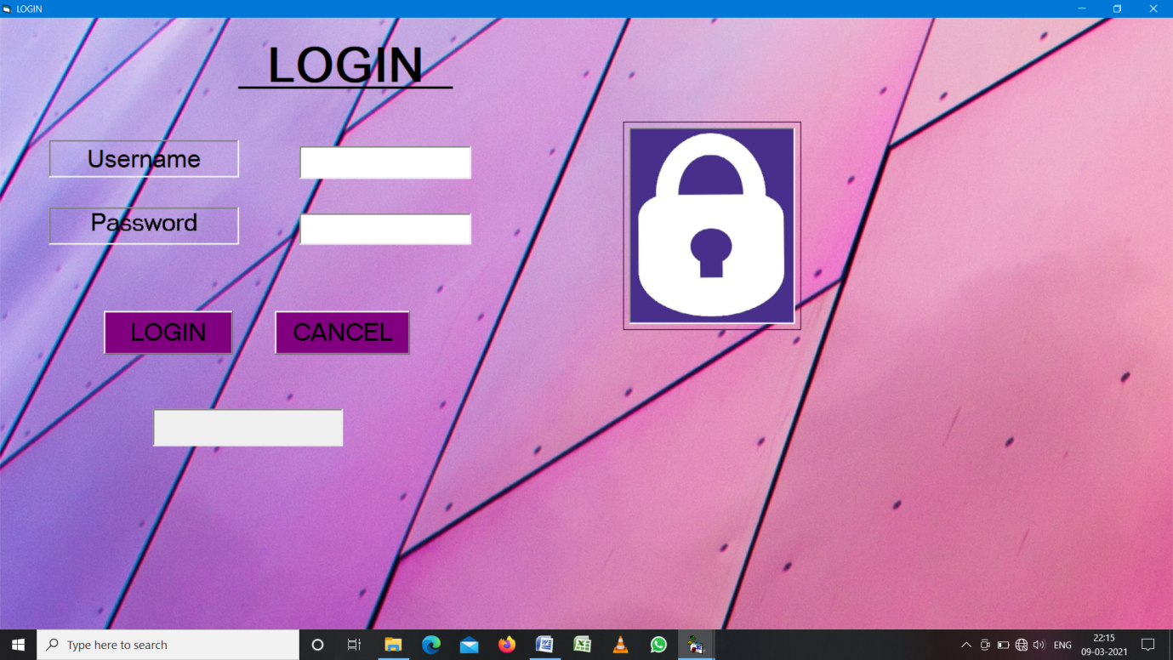

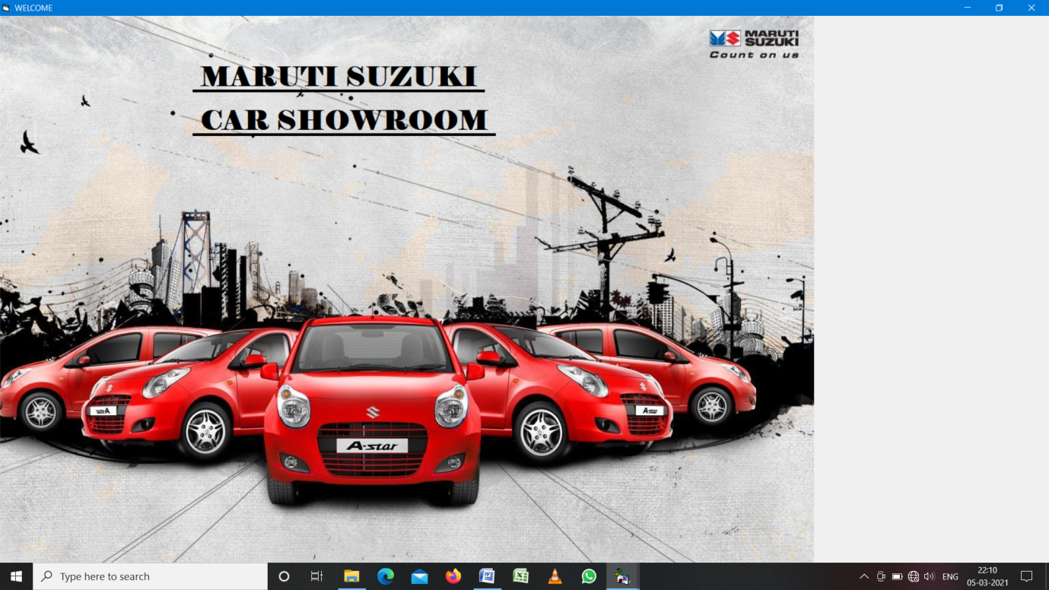

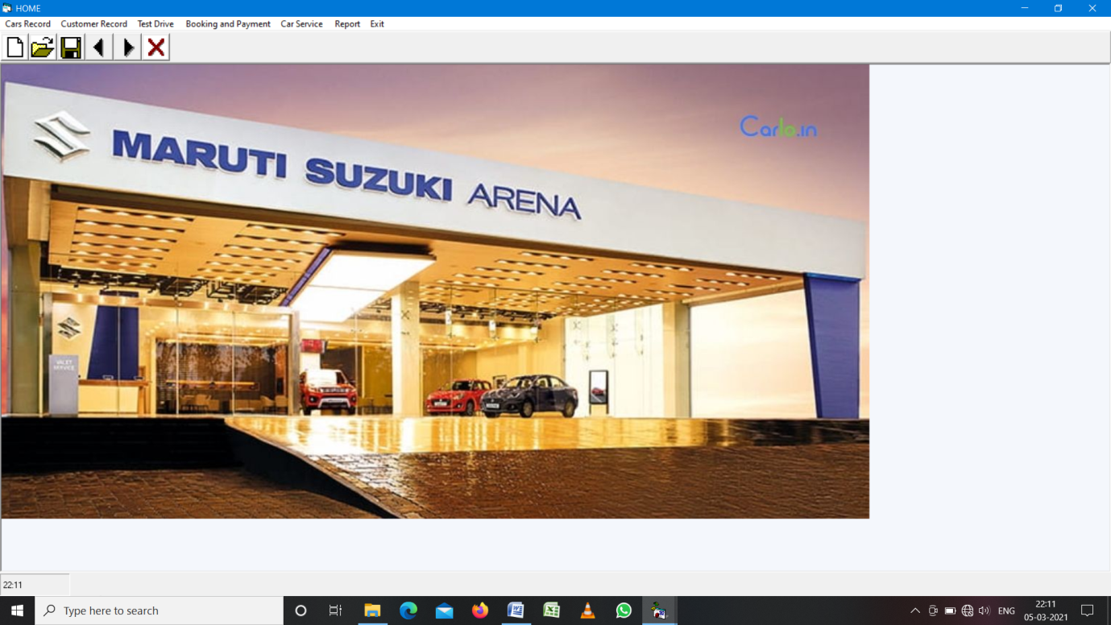

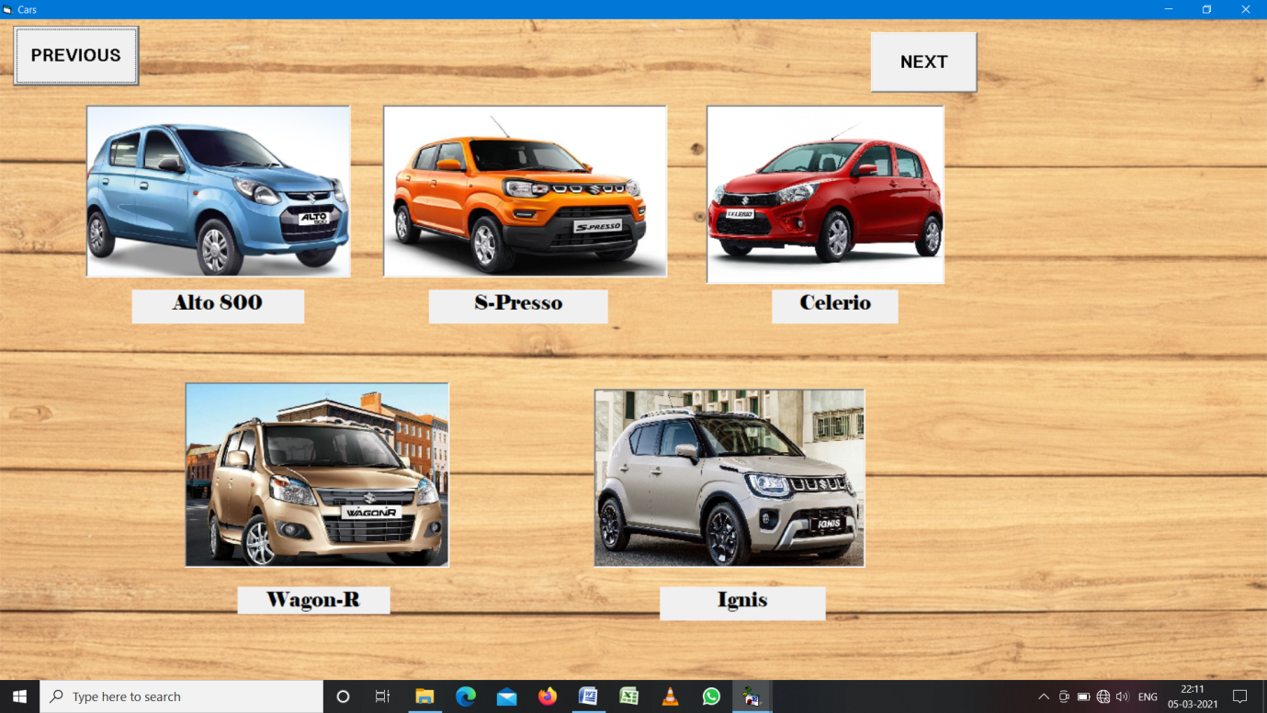

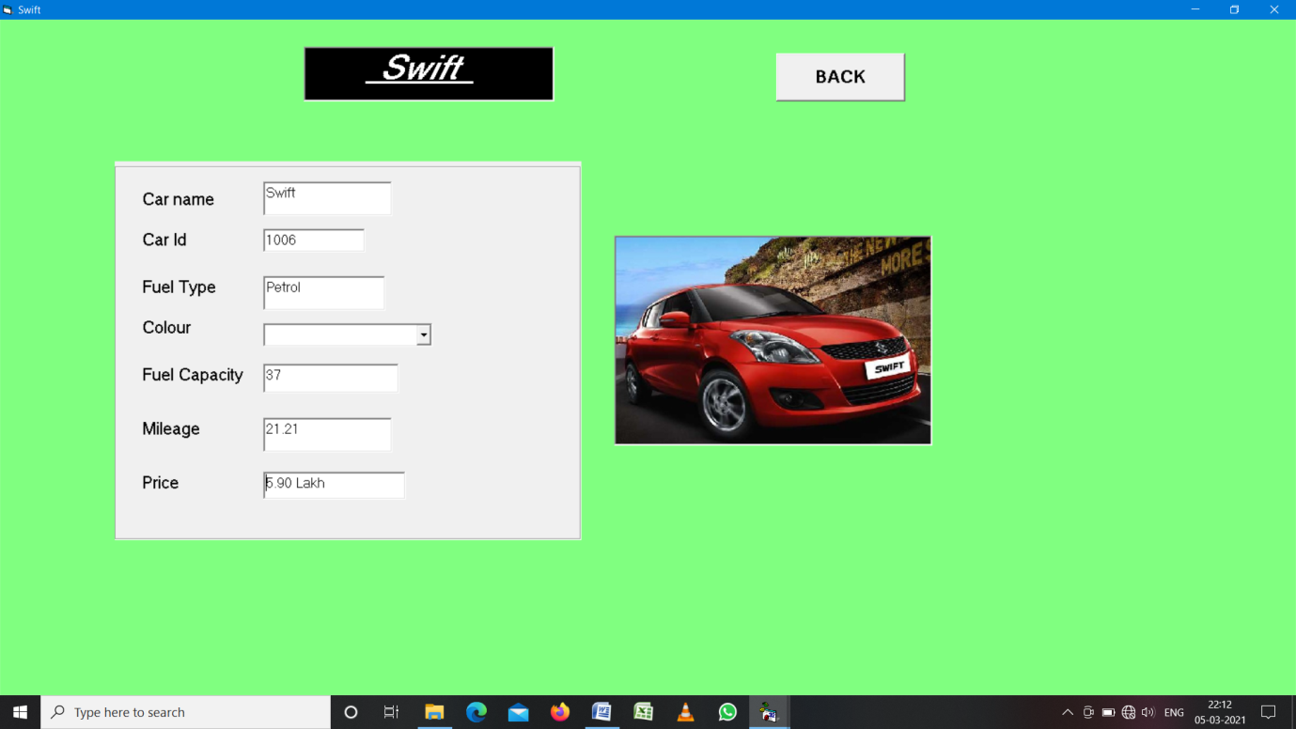

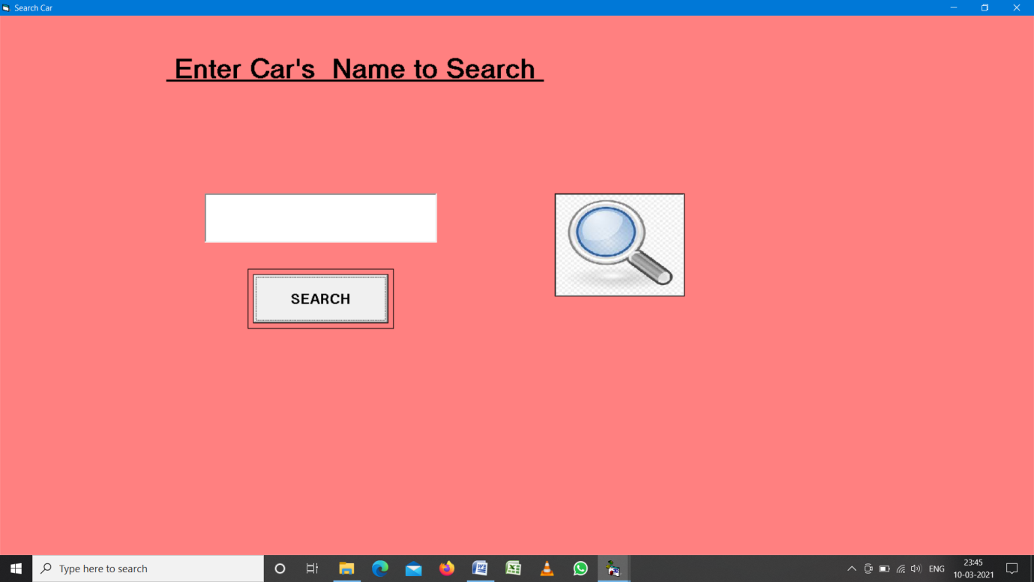

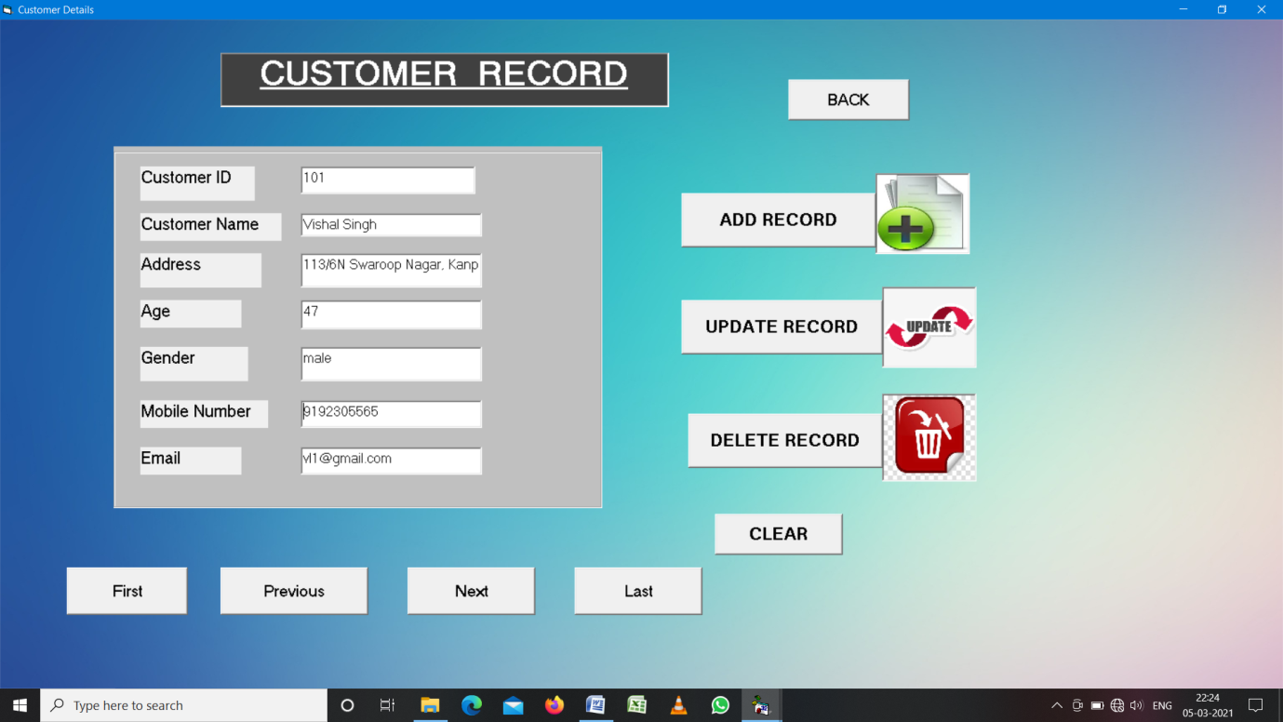

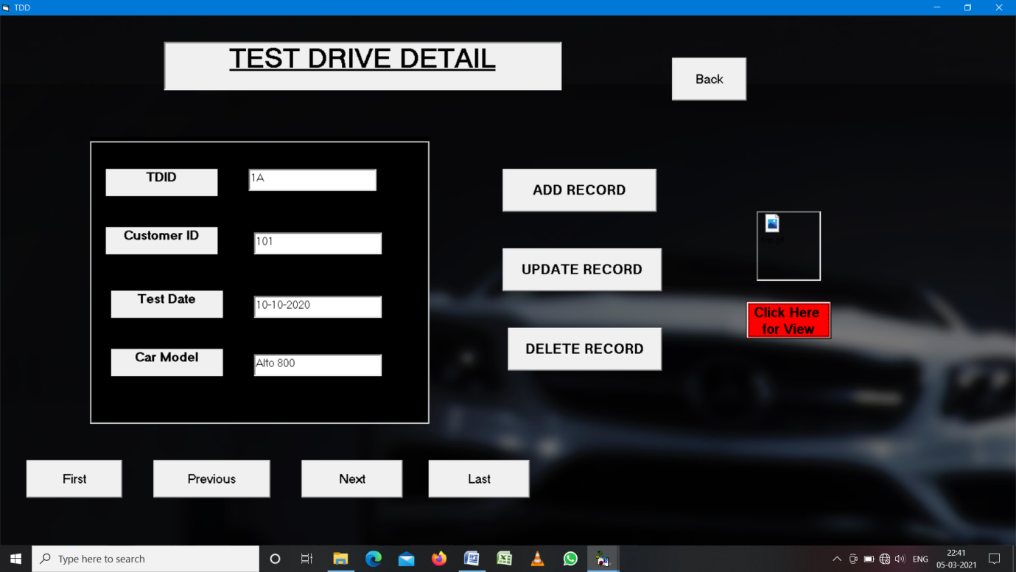

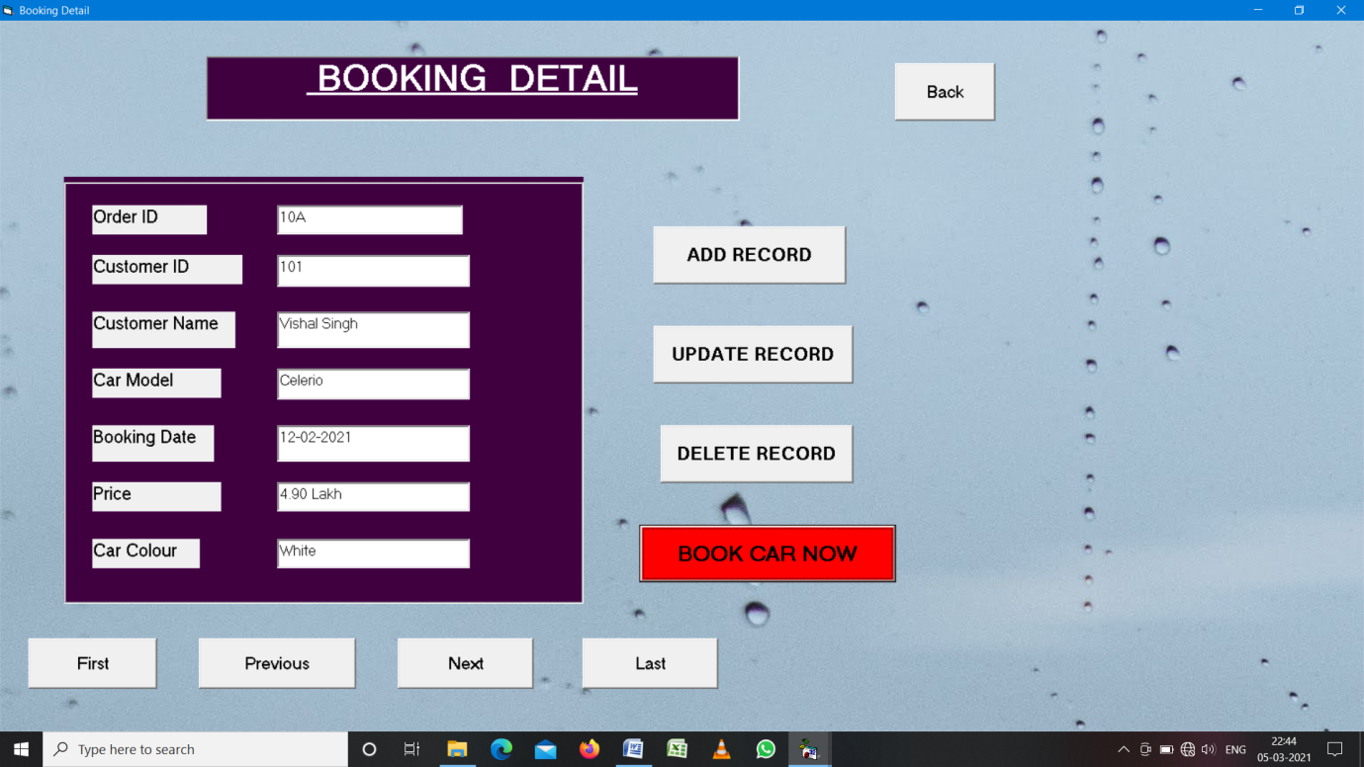

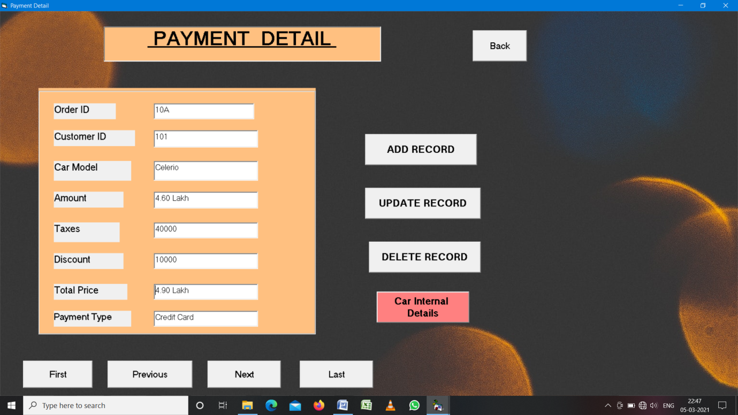

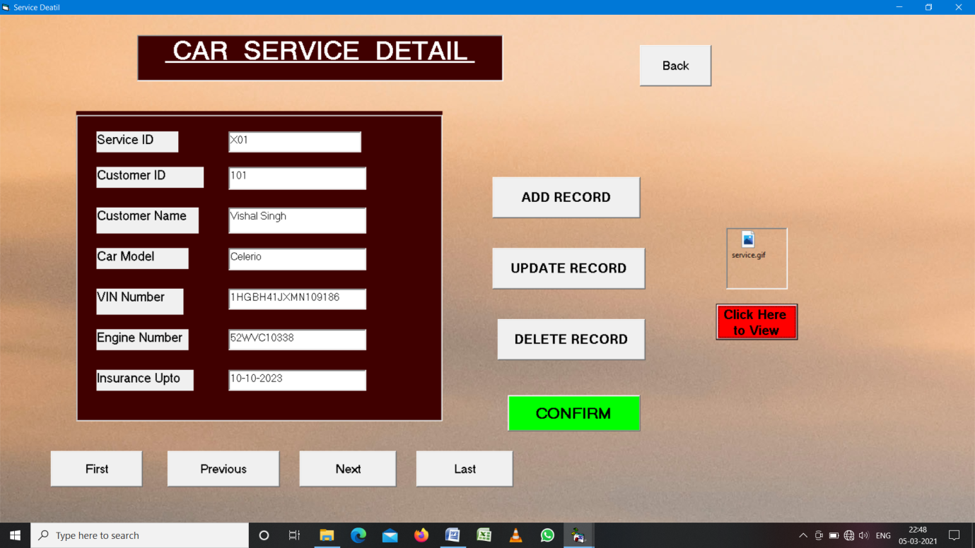

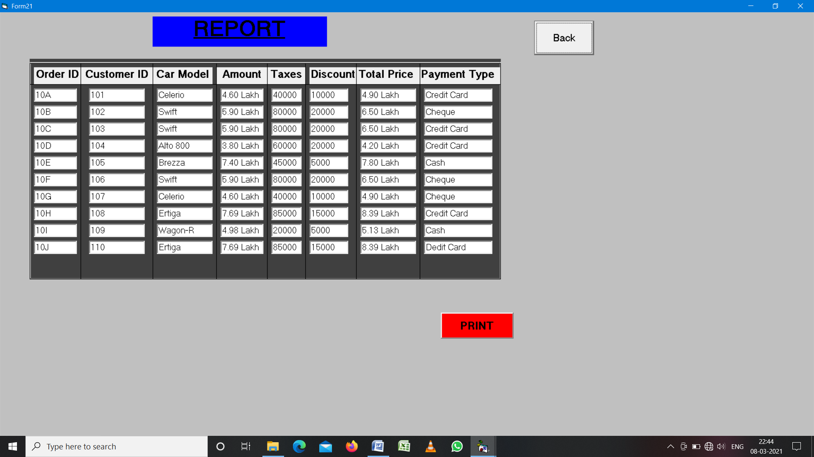

**CODING**

Private Sub Command1_Click()

Dim user As String

Dim pass As String

user = "priyanshi"

pass = "mypro1"

If (user = Username.Text And pass = Password.Text) Then

MsgBox "Login Successful"

Timer1.Enabled = True

Else

MsgBox "Login Failed"

End If

End Sub

Private Sub Command2_Click()

End

End Sub

Private Sub Timer1_Timer()

ProgressBar1.Value = ProgressBar1 + 5

If ProgressBar1.Value = ProgressBar1.Max Then

Timer1.Enabled = False

Unload Me

Form2.Show

End If

End Sub

Private Sub Image1_Click()

MDIForm1.Show

End Sub

Private Sub add_book_Click()

Form18.Show

End Sub

Private Sub add_cust_Click()

Form16.Show

End Sub

Private Sub add_pay_Click()

Form19.Show

End Sub

Private Sub add_service_Click()

Form20.Show

End Sub

Private Sub add_td_Click()

Form17.Show

End Sub

Private Sub del_book_Click()

Form18.Show

End Sub

Private Sub del_cust_Click()

Form16.Show

End Sub

Private Sub del_pay_Click()

Form19.Show

End Sub

Private Sub del_service_Click()

Form20.Show

End Sub

Private Sub del_td_Click()

Form17.Show

End Sub

Private Sub exit_out_Click()

End

End Sub

Private Sub rep_Click()

Form21.Show

End Sub

Private Sub search_car_Click()

Form15.Show

End Sub

Private Sub upd_book_Click()

Form18.Show

End Sub

Private Sub upd_cust_Click()

Form16.Show

End Sub

Private Sub upd_pay_Click()

Form19.Show

End Sub

Private Sub upd_service_Click()

Form20.Show

End Sub

Private Sub upd_td_Click()

Form17.Show

End Sub

Private Sub view_book_Click()

Form18.Show

End Sub

Private Sub view_car_Click()

Form3.Show

End Sub

Private Sub view_cust_Click()

Form16.Show

End Sub

Private Sub view_pay_Click()

Form19.Show

End Sub

Private Sub view_service_Click()

Form20.Show

End Sub

Private Sub view_td_Click()

Form17.Show

End Sub

Private Sub Command1_Click()

MDIForm1.Show

End Sub

Private Sub Command2_Click()

Form4.Show

End Sub

Private Sub Image1_Click()

Form5.Show

End Sub

Private Sub Image2_Click()

Form6.Show

End Sub

Private Sub Image3_Click()

Form7.Show

End Sub

Private Sub Image4_Click()

Form8.Show

End Sub

Private Sub Image5_Click()

Form9.Show

End Sub

Private Sub Command1_Click()

Form3.Show

End Sub

Private Sub Image1_Click()

Form10.Show

End Sub

Private Sub Image2_Click()

Form11.Show

End Sub

Private Sub Image3_Click()

Form12.Show

End Sub

Private Sub Image4_Click()

Form13.Show

End Sub

Private Sub Image5_Click()

Form14.Show

End Sub

Private Sub Command1_Click()

Form3.Show

End Sub

Private Sub Form_Load()

Combo1.AddItem "Green"

Combo1.AddItem "Blue"

Combo1.AddItem "White"

Combo1.AddItem "Silver"

End Sub

Private Sub Command1_Click()

Form3.Show

End Sub

Private Sub Form_Load()

Combo1.AddItem "Grey"

Combo1.AddItem "Blue"

Combo1.AddItem "White"

Combo1.AddItem "Orange"

Combo1.AddItem "Red"

End Sub

Private Sub Command1_Click()

Form3.Show

End Sub

Private Sub Form_Load()

Combo1.AddItem "Grey"

Combo1.AddItem "Blue"

Combo1.AddItem "White"

Combo1.AddItem "Orange"

Combo1.AddItem "Red"

Combo1.AddItem "Silver"

End Sub

Private Sub Command1_Click()

Form3.Show

End Sub

Private Sub Form_Load()

Combo1.AddItem "Brown"

Combo1.AddItem "Silver"

Combo1.AddItem "White"

Combo1.AddItem "Orange"

End Sub

Private Sub Command1_Click()

Form3.Show

End Sub

Private Sub Form_Load()

Combo1.AddItem "Grey"

Combo1.AddItem "Blue"

Combo1.AddItem "White"

Combo1.AddItem "Orange"

Combo1.AddItem "Red"

Combo1.AddItem "Silver"

End Sub

Private Sub Command1_Click()

Form4.Show

End Sub

Private Sub Form_Load()

Combo1.AddItem "Grey"

Combo1.AddItem "Silver"

Combo1.AddItem "White"

Combo1.AddItem "Orange"

Combo1.AddItem "Red"

Combo1.AddItem "Blue"

End Sub

Private Sub Command1_Click()

Form4.Show

End Sub

Private Sub Form_Load()

Combo1.AddItem "Grey"

Combo1.AddItem "White"

Combo1.AddItem "Red"

Combo1.AddItem "Blue"

End Sub

Private Sub Command1_Click()

Form4.Show

End Sub

Private Sub Form_Load()

Combo1.AddItem "Grey"

Combo1.AddItem "White"

Combo1.AddItem "Brown"

Combo1.AddItem "Red"

Combo1.AddItem "Blue"

End Sub

Private Sub Command1_Click()

Form4.Show

End Sub

Private Sub Form_Load()

Combo1.AddItem "Grey"

Combo1.AddItem "Silver"

Combo1.AddItem "White"

Combo1.AddItem "Orange"

Combo1.AddItem "Red"

Combo1.AddItem "Blue"

Combo1.AddItem "Brown"

Combo1.AddItem "Black"

Combo1.AddItem "Green"

End Sub

Private Sub Command1_Click()

Form4.Show

End Sub

Private Sub Form_Load()

Combo1.AddItem "Grey"

Combo1.AddItem "Silver"

Combo1.AddItem "White"

Combo1.AddItem "Red"

Combo1.AddItem "Blue"

End Sub

Private Sub Command1_Click()

If Text1 = "Alto 800" Then

Form5.Show

ElseIf Text1 = "S-Presso" Then

Form6.Show

ElseIf Text1 = "Celerio" Then

Form7.Show

ElseIf Text1 = "Wagon-R" Then

Form8.Show

ElseIf Text1 = "Ignis" Then

Form9.Show

ElseIf Text1 = "Swift" Then

Form10.Show

ElseIf Text1 = "Baleno" Then

Form11.Show

ElseIf Text1 = "Dzire" Then

Form12.Show

ElseIf Text1 = "Brezza" Then

Form13.Show

ElseIf Text1 = "Ertiga" Then

Form14.Show

Else

MDIForm1.Show

End If

End Sub

Private Sub Command1_Click()

customerdb.Recordset.MoveFirst

End Sub

Private Sub Command2_Click()

customerdb.Recordset.MovePrevious

End Sub

Private Sub Command3_Click()

customerdb.Recordset.MoveNext

End Sub

Private Sub Command4_Click()

customerdb.Recordset.MoveLast

End Sub

Private Sub Command5_Click()

MDIForm1.Show

End Sub

Private Sub Command6_Click()

customerdb.Recordset.AddNew

End Sub

Private Sub Command7_Click()

customerdb.Recordset.Fields("Customer ID") = Text1.Text

customerdb.Recordset.Fields("Customer Name") = Text2.Text

customerdb.Recordset.Fields("Address") = Text3.Text

customerdb.Recordset.Fields("Age") = Text4.Text

customerdb.Recordset.Fields("Gender") = Text5.Text

customerdb.Recordset.Fields("Mobile Number") = Text6.Text

customerdb.Recordset.Fields("Email") = Text7.Text

customerdb.Recordset.Update

MsgBox "Updation Succesfully Done"

End Sub

Private Sub Command8_Click()

customerdb.Recordset.Delete

MsgBox "Record Deleted"

End Sub

Private Sub Command9_Click()

Text1.Text = ""

Text2.Text = ""

Text3.Text = ""

Text4.Text = ""

Text5.Text = ""

Text6.Text = ""

Text7.Text = ""

End Sub

Private Sub Command1_Click()

MDIForm1.Show

End Sub

Private Sub Command2_Click()

testdrivedb.Recordset.MoveFirst

End Sub

Private Sub Command3_Click()

testdrivedb.Recordset.MovePrevious

End Sub

Private Sub Command4_Click()

testdrivedb.Recordset.MoveNext

End Sub

Private Sub Command5_Click()

testdrivedb.Recordset.MoveLast

End Sub

Private Sub Command6_Click()

testdrivedb.Recordset.AddNew

End Sub

Private Sub Command7_Click()

testdrivedb.Recordset.Fields("TDID") = Text1.Text

testdrivedb.Recordset.Fields("Customer Id") = Text2.Text

testdrivedb.Recordset.Fields("Date") = Text3.Text

testdrivedb.Recordset.Fields("Car Model") = Text4.Text

testdrivedb.Recordset.Update

MsgBox "Updation Succesfully Done"

End Sub

Private Sub Command8_Click()

testdrivedb.Recordset.Delete

MsgBox "Record Deleted"

End Sub

Private Sub Command9_Click()

OLE1.CreateEmbed "C:\Users\Shubh K\Desktop\trip.gif"

End Sub

Private Sub Command1_Click()

MDIForm1.Show

End Sub

Private Sub Command2_Click()

bookingdb.Recordset.MoveFirst

End Sub

Private Sub Command3_Click()

bookingdb.Recordset.MovePrevious

End Sub

Private Sub Command4_Click()

bookingdb.Recordset.MoveNext

End Sub

Private Sub Command5_Click()

bookingdb.Recordset.MoveLast

End Sub

Private Sub Command6_Click()

bookingdb.Recordset.AddNew

End Sub

Private Sub Command7_Click()

bookingdb.Recordset.Fields("Order ID") = Text1.Text

bookingdb.Recordset.Fields("Customer ID") = Text2.Text

bookingdb.Recordset.Fields("Customer Name") = Text3.Text

bookingdb.Recordset.Fields("Car Model") = Text4.Text

bookingdb.Recordset.Fields("Booking Date") = Text5.Text

bookingdb.Recordset.Fields("Price") = Text6.Text

bookingdb.Recordset.Fields("Car Colour") = Text7.Text

bookingdb.Recordset.Update

MsgBox "Updation Succesfully Done"

End Sub

Private Sub Command8_Click()

bookingdb.Recordset.Delete

MsgBox "Record Deleted"

End Sub

Private Sub Command9_Click()

MsgBox " Want to buy a Car "

Form19.Show

End Sub

Private Sub Command1_Click()

MDIForm1.Show

End Sub

Private Sub Command2_Click()

paydb.Recordset.MoveFirst

End Sub

Private Sub Command3_Click()

paydb.Recordset.MovePrevious

End Sub

Private Sub Command4_Click()

paydb.Recordset.MoveNext

End Sub

Private Sub Command5_Click()

paydb.Recordset.MoveLast

End Sub

Private Sub Command6_Click()

paydb.Recordset.AddNew

End Sub

Private Sub Command7_Click()

paydb.Recordset.Fields("Order ID") = Text1.Text

paydb.Recordset.Fields("Customer ID") = Text2.Text

paydb.Recordset.Fields("Car Model") = Text3.Text

paydb.Recordset.Fields("Amount") = Text4.Text

paydb.Recordset.Fields("Taxes") = Text5.Text

paydb.Recordset.Fields("Discount") = Text6.Text

paydb.Recordset.Fields("Total Price") = Text7.Text

paydb.Recordset.Fields("Payment Type") = Text8.Text

paydb.Recordset.Update

MsgBox "Updation Succesfully Done"

End Sub

Private Sub Command8_Click()

paydb.Recordset.Delete

MsgBox "Record Deleted"

End Sub

Private Sub Command9_Click()

Form20.Show

End Sub

Private Sub Command1_Click()

MDIForm1.Show

End Sub

Private Sub Command10_Click()

MsgBox "BOOKING DONE"

End Sub

Private Sub Command2_Click()

servicedb.Recordset.MoveFirst

End Sub

Private Sub Command3_Click()

servicedb.Recordset.MovePrevious

End Sub

Private Sub Command4_Click()

servicedb.Recordset.MoveNext

End Sub

Private Sub Command5_Click()

servicedb.Recordset.MoveLast

End Sub

Private Sub Command6_Click()

servicedb.Recordset.AddNew

End Sub

Private Sub Command7_Click()

servicedb.Recordset.Fields("Service ID") = Text1.Text

servicedb.Recordset.Fields("Customer ID") = Text2.Text

servicedb.Recordset.Fields("Customer Name") = Text3.Text

servicedb.Recordset.Fields("Car Model") = Text4.Text

servicedb.Recordset.Fields("VIN Number") = Text5.Text

servicedb.Recordset.Fields("Engine Number") = Text6.Text

servicedb.Recordset.Fields("Insurance Upto") = Text7.Text

servicedb.Recordset.Update

MsgBox "Updation Succesfully Done"

End Sub

Private Sub Command8_Click()

servicedb.Recordset.Delete

MsgBox "Record Deleted"

End Sub

Private Sub Command9_Click()

OLE1.CreateEmbed "C:\Users\Shubh K\Desktop\service.gif"

End Sub

Private Sub Command1_Click()

CommonDialog1.ShowPrinter

End Sub

Private Sub Command2_Click()

MDIForm1.Show

End Sub